**TOWNSVIEW SCHOOL**

**2025-2026 SCHOOL SUPPLY LIST: Grade 1 English**

* 1 pack of 24 Crayola crayons
* 1 pack of 10 Crayola washable markers – original colors
* 2 packages of 24 pencil crayons
* 1 package 12 HB Pencils
* 2 white erasers
* 1 pair of scissors
* 1 poly duo-tang report cover-yellow
* 2 Large UHU glue sticks
* 2 poly duo-tangs
* 6 Black Dry Erase markers (chisel tip)
* 2 Hilroy exercise notebooks (½ plain & ½ ruled - yellow) See picture:

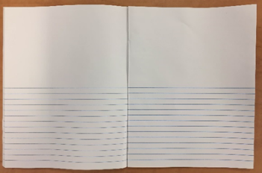

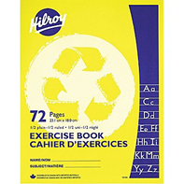

* 2 package of clear plastic page protectors (10 per package)
* 2 boxes of Kleenex
* 1 box of large Ziploc bags (15 per box)
* 1 box of sandwich Ziploc bags

**NOTES:**

* In addition to the school supplies, students will need: a refillable water bottle, lunch box, book bag and indoor sneakers with non-marking soles for Phys. Ed and the classroom. (Please put your child’s name on each of these items, so it is easier to find them if they become lost).
* The purchasing of the K-5 school supplies package is optional. The cost to purchase the school supply pack will be $65.00. **This option to purchase a school supply pack for your child will only be available up until Tuesday, June 24, 2025.** After that date, you will be responsible to purchase your child’s school supplies.
* If you wish to buy a school pack, payment can be made by cash, by cheque (cheques made payable to Townsview School using School Cash Online. <https://district.schoolcashonline.com/>