TOWNSVIEW SCHOOL
2023-2024 SCHOOL SUPPLY LIST: KINDERGARTEN

- 1 package of 24 Crayola pre-sharpened pencil crayons
- 1 package of 24 Crayola crayons
- 2 packages of 10 Crayola markers
- 2 packages of 12 HB pencils (Blue Staedtler Brand)
- 2 white erasers with white plastic covers (Basic brand or Staedtler brand)
- 2 Elmers Glue Sticks
- 2 poly duo-tang report covers (plastic) - blue
- 2 poly duo-tang report covers (plastic) - orange
- 2 poly duo-tang report covers (plastic) - red
- 2 Hilroy Exercise Books (40 Page)
- 1 Hilroy green exercise book – ½ plain & ½ interlined - looks like this:
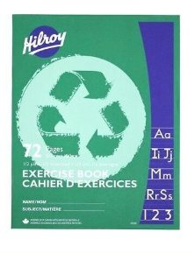
- 2 Expo dry erase markers (blue)
- 2 boxes of Kleenex
- 2 boxes of large Ziploc bags
- 1 package Lysol wipes (80 count)
______________________________________________________________________________

NOTES:

- In addition to the school supplies, students will need: a refillable water bottle, lunch box, book bag and indoor sneakers with non-marking soles for Phys. Ed and the classroom. (Please put your child’s name on each of these items, so it is easier to find them if they become lost).

- The purchasing of the K-5 school supplies package is optional. Please note that all items being purchased at the school will include the 4% ASDW convenience fee, plus tax. The cost to purchase the school supply pack will be $60.00.

- If you wish to buy a school pack, payment can be made by cash, by cheque (cheques made payable to Townsview School using School Cash Online. https://district.schoolcashonline.com/. When you pay by school cash online, please print your transaction receipt for your records. Our preferred method of payment would be by School Cash Online.

- This option to purchase a school supply pack for your child will only be available up until Friday, June 23, 2023. After this date, we will be asking parents/guardians to purchase their child’s school supplies themselves. Thank you.

